<Google Classroom>

**Online Learning Platform**

Use-Case-Realization Specification: <View Scheduling>

Version <1.1>

Revision History

| **Date** | **Version** | **Description** | **Author** |
| --- | --- | --- | --- |
| 05/12/2021 | 1.0 | Initial version | Le Hong Hai |
| 09/12/2021 | 1.1 | Edited version | LE Hong Hai |
|  |  |  |  |
|  |  |  |  |

Table of Contents

1. Introduction 2

1.1 Purpose 2

1.2 Scope 2

1.3 Definitions, Acronyms, and Abbreviations 2

1.4 References 2

1.5 Overview 2

2. Flow of Events—Design 2

3. Derived Requirements 2

Use-Case-Realization Specification: <View Schedule>

# Introduction

-This process for user to view Schedule in Google Classroom

- For who: users

## Purpose

- The purpose: helping users to know schedule and to-do-lists in every class they’ve taken part in

## Scope

## Definitions, Acronyms, and Abbreviations

## References

## Overview

# Flow of Events—Design

## sequence diagram

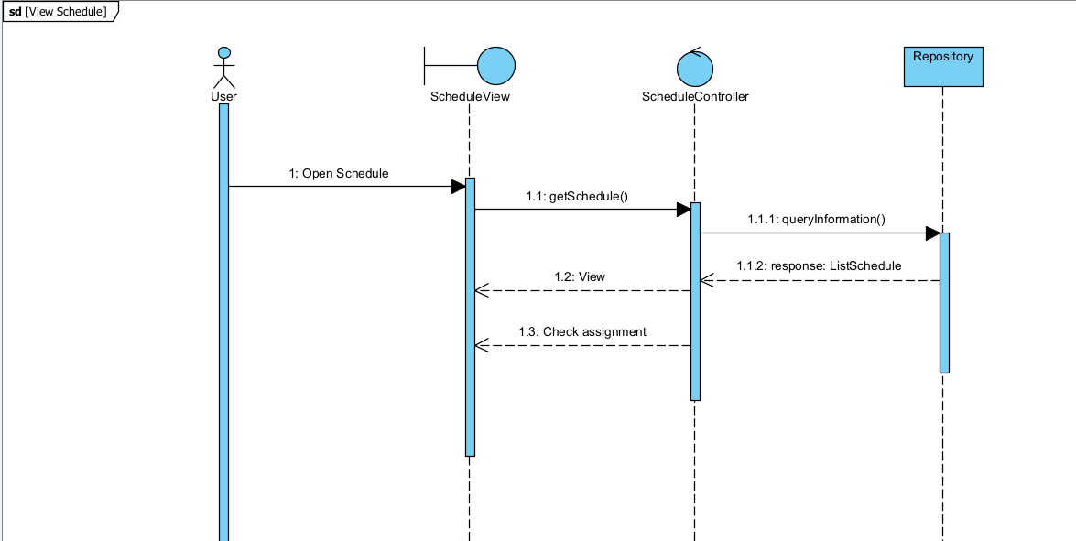

## class diagram

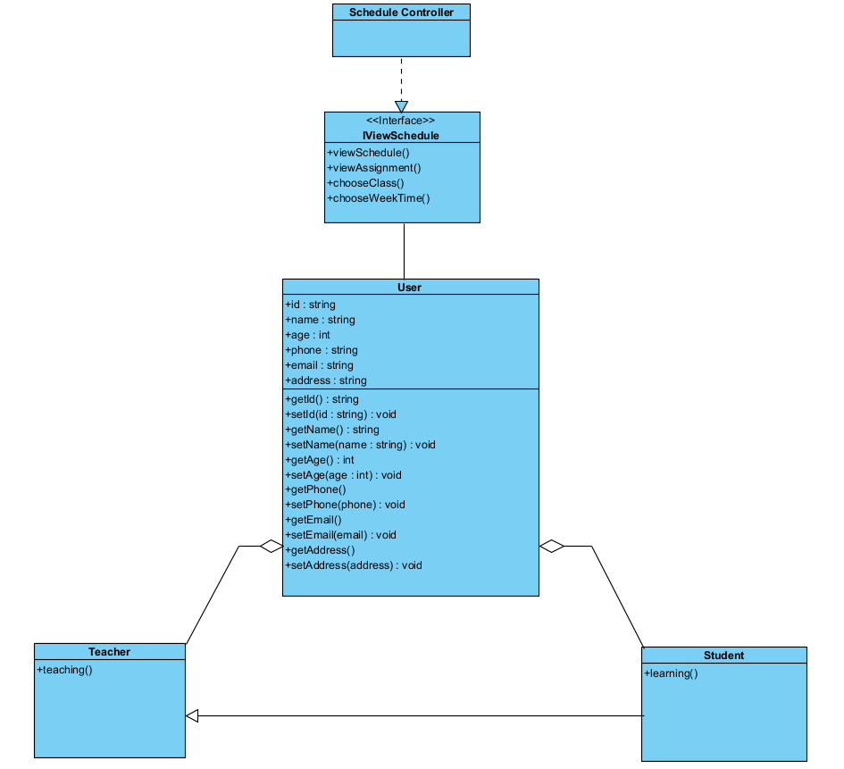

# Derived Requirements

None